Felinfach Community Council
Agenda for Regular Meeting to be held at Llanfilo Hall
On Tuesday 10th October 2023
6.30pm

Register of attendees will be taken.

Apologies.

Any other business for agenda.

Minutes of last meeting

Declaration of interest

Actions

Actions( August 2023) Planning Application 21/1494/FUL Golwy-y-Mynydd

Actions (August 2023) Website Support – response from Data Etc.

Flood defence in Felinfach – Update

2. Planning

2.1 – Planning Application responses to Powys County Council.

2.2 - Application Reference: 23/1297/FUL Grid Reference: E:310968 N: 236047
Proposal: Erection of a steel-framed building to cover existing muck store
Site Address: Maescoed , Llandefalle, Brecon, LD3 0ND – previously discussed with Planning Committee. It was resolved that no objection would be made, Clerk advised PCC Planning committee of decision.

FYI - Planning decisions 14-19th September

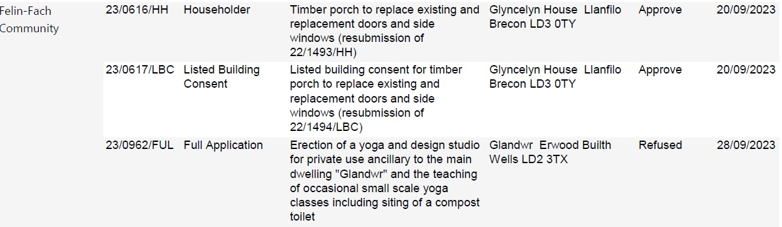

3.0 - Correspondence

3.1 – Change of Meeting Night?

  - – New signs for Play Park.

  - Llandefalle Hill Gate, Felinfach Side.

4- Reports – No Reports

5 - County Councillor Report.

6 - Finance

6.1 - Balance of Accounts

Invoices to be paid – Swansea & Brecon Diocesan £100.00
Jeff Price(Kiosk Painting £120.00
Card Payment previously authorised by Committee – SLCC £72.00 (Clerks Seminar)

6.2 – External Audit Conclusion

6.3 – 2nd Quarterly Accounts

Point of Interest

Thank you letter from Wales Air Ambulance & Dial-a-ride for donation.
Community Heartbeat has replaced the battery for the Defibrillator, free of charge.

Chairman’s Business

Date of next meeting

Correspondence

3.1 –
ATTENDANCE FOR 2023-2024
 | APRIL | MAY | JUNE | JULY | AUGUST
ATTENDED | 6 | 8 | 5 | 7 | 3
ABSENT | 3 | 1 | 4 | 2 | 6

