Felinfach Community Council
Agenda for Regular Meeting to be held at Maes-y-Bellan Chapel
On Tuesday 27th September 2022
6.30pm

Register of attendees will be taken

Apologies.

Any other business for agenda.

Minutes of last meeting

Declaration of interest

Actions

3.5 (Aug) Training Plan – Set training Plan

3.2 –(Aug) Crassula mites at Brechfa Pool – Questions & Answers from Suzy Wood from Cabi / possible presentation at meeting, awaiting confirmation.

3.3 – (Aug) Grid reference SO 0987 3410 – Right of Way footpath between Trehenry Fawr & Duck Pond Wood above Felinfach – Request for O/S map.

2. Planning

2.1 - Application Reference: 22/1493/HH Grid Reference: E:308575 N: 232725
Proposal: Erection of a new timber porch to replace existing with new internal doors
and windows Site Address: Glyncelyn House , Llanfilo, Brecon, LD3 0TY

2.2 - Application Reference: 22/1494/LBC Grid Reference: E:308575 N: 232725
Proposal: Listed building consent for erection of new timber porch to replace
existing including new internal doors and windows Site Address: Glyncelyn House , Llanfilo, Brecon, LD3 0TY

Powys Replacement Local Development Plan (LDP) – opportunity to comment on review.

FYI

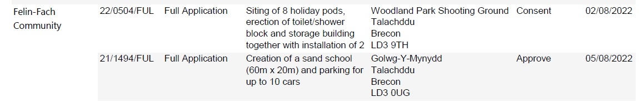
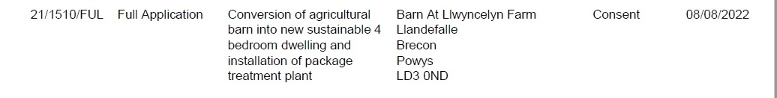

Felin-Fach Community 22/0583/HH Alterations to the dwelling Brookfield Approve
including the replacement of Pont-Y-Wal Lane
a single storey garden room Bronllys
extension with a two-storey Brecon

3.0 - Correspondence

3.1 – ½ yearly Donations:
Kids Cancer Charity
Brecon & District Disabled Club
Cerebral Palsy
Tenovus Cancer Care
Breconshire & Radnorshire Urdd

3.2 – Social media policy– quotation from Data Etc. social media policy template.
3.3 – Biodiversity “It’s for them” campaign
3.4 – Health Check for Clerk & Councillors
3.5 – PCSO Trudy Davies – introducing herself.

Reports – No Reports

County Councillor Report.

Finance

Balance of Accounts

Invoices to be paid – Audit Wales invoice for 2020-2021 audit.

Signature for 1st quarter accounts

Point of Interest
Electronic Bus timetable in Llandefalle.

Chairman’s Business - Date of next meeting

ACTIONS

3.2 –(Aug) Crassula mites at Brechfa Pool – Questions & Answers from Suzy Wood from Cabi / possible presentation at meeting, awaiting confirmation.

Hello Delyth

Thank you for getting in touch, and apologies for not contacting you sooner. The visit went well thank you – we met Cllr Gareth Price just as we arrived and explained things further to him and gave him some more of our leaflets for distribution amongst the council. We also spoke to a local lady whose elderly parents leave at the nearby farm, and she was extremely interested in what we were doing and pleased to be able to speak with us.

The good news is that the mites are doing relatively well despite the heatwaves and drought, and have spread beyond the original release patches, with some signs of spread to edge of the fenced off area. However, you can see the difference in the height of the vegetation between inside and outside of the fencing, and our worry is that the progress that has been made in trying to establish the mites may be hampered by grazing. Knowing that the fencing is prone to being flattened by the ponies and curious sheep (thanks I think go to Gareth for the repairs so far!), we would like to request that more robust fencing could be put in place sooner rather than later. @Gall, Moyrah – would you be able to remind me what the latest was with sourcing materials and labour please?

Correspondence
3.2 -social media Policy
Hi Delyth,
I would research, write, and upload to website for £40. Let me know your thoughts.
Kind regards Charlotte

