Felinfach Community Council
Agenda for Regular Meeting to be held at Llanfilo Old School
On Wednesday 9 July 2025
6.30pm

Register of attendees will be taken.

Apologies.

Declaration of interest

Minutes of last meeting

Actions

3.1 - Renewal of insurance policy for 2025-2026 from Zurich. – Llanfilo Defibrillator added to Council’s insurance policy.

2. Planning.

2.1 - Application 25/0770/FUL Golwg-y-Mynydd holiday let– Response sent to Planning Department.
2.2 - Update on Planning Application 21/1494/FUL

2.3 -Application 25/0796/FUL - change of use of building and land to use as storage, Pont-y-Bat Farm, Llandefalle.

FYI
Application 23/1786/FUL – Refusal of One Planet Development.

3.0 - Correspondence

3.1 - Felinfach Play Park – Breach of rules regarding dogs.

3.2 – Hedges & Potholes within the ward.

3.3 - Biodiversity – Setting S6 Plan for 2025-2026 – update from Mr. Chair
& any new ideas
3.4 - Community Conversations: Shaping the Future of Powys Communities
4 - Reports – None

5 - County Councillor Report.

6 - Finance

6.1 - Balance of Accounts

6.2 - Balance transferable to Reserve Account, with adequate funds remaining for expenditure.
6.3 - – Acceptance of Financial Regulations 2025-2026 – Please all Councillors read financial regulations to be confirmed as fit for purpose.

Invoices to be paid – Microsoft 365 84.99
Bitdefender 84.99

Income- None

Point of Interest
Rubbish left in Kiosk Brynhaul & Felinfach.
Freedom of information request on drain inspection in Felinfach from Sue Loveday.

Chairman’s Business

Sharing the load

Date of next meeting

CORRESPONDENCE

2.2 - Reply from Adam Nickson, Planning enforcement Officer on Golwg-y-Mynnydd site

Good Morning

I visited the site and inspected the static caravan. The landowner claims that they have some form of consent for its placement; however, I am unable to verify this on my end. I have therefore requested that they forward the relevant documentation to me for review. Additionally, I have asked for the register that must be maintained for all visitors to the site, as required under Condition 17.

I also requested an update on the passing bays, as no work commenced when I visited the site a week ago. I understand that a plan for the bays had been discussed with the highways team, particularly as bay three would have required significant earthworks to bring it up to road level. It has now been agreed that the bay three will be repositioned slightly to reduce the amount of work needed for its installation. Bay one, however, must be constructed to adoptable standards, and the landowner has been informed of this requirement.

Kind Regards

Adam Nickson

Planning Enforcement Officer

3.1 - Felinfach Play Park – Breach of rules regarding dogs, New signs erected on both gates

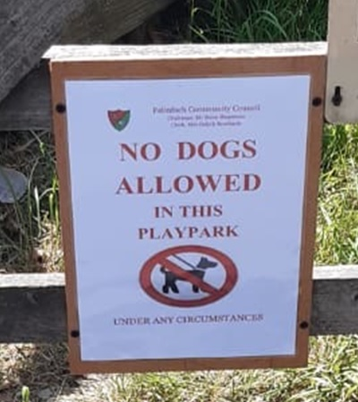

3.2 - Message from Powys County Council – Highways regarding Hedge Cutting & Potholes

Morning Del,

I have been informed that the hedges within the area are all due to be to be cut as per schedule, it's a very vast area to cover but I hope this will be soon, we have received a large number of hedge cutting reports within the area, as you can imagine with the weather we have had they have been growing well this season. I have copied in Allun just to make him aware of the area in question, he may be able to provide a more accurate time frame on this specific location.

With regards to the potholes within the area, we have a few works orders created for pothole repairs through the area of Felinfach, the ones you mention are within these works orders, all of which are within date response/reaction times, just to shed some light on the situation we have in excess of 300 works orders in the Brecon area alone which we are aiming to get to as soon as possible, if you notice any significant changes to the deterioration of the listed defects bellow please get in touch with me / respond to this email thread and I can come are re assess the defects and prioritize accordingly.

I know this may not fully fulfil your request but we hope to address these issues as soon as possible.

Kindest regards,

Dai.

